ONLINE WAREHOUSE

G.B.V.S. KRISHNA (141FA04012)

RUTHVIK PREM KUMAR (141FA04011)

P.MAHESH (141FA04039)

Y.V.GOPI KRISHNA (141FA04059)

Table of Contents

Page
1 INTRODUCTION

1.1 About Project……………………………………………………3
1.2 Scope………………………..………………………………………3
1.3 Project plan…………………………………………………………4
1.4 Constraints………………………………………………………….4
1.5 Guidelines…………………………………………………………..5

2 PROBLEM DEFINITION

2.1 Existing System: ……………………………………...................5
2.2 Proposed System:………………………………………………..6

3 SYSTEM ANALYSIS

3.1 System Design………………………………………………………………6
3.2 Functional Requirements ……………………………………………7
3.3 Non functional Requirements………………………………………..8
3.4 Modules………………………………………………………………………8

4 MODELLING
4.1 Usecase Diagram for Admin…………………………………………….10
4.2 Usecase Diagram for Employee…………………………………………11
4.3 Usecase Diagram for Customer………………………………………….12.

5 HARDWARE REQUIREMENTS ............................................................13

6 SOFTWARE REQUIREMENTS………………………………………..13

7 INTERFACES…………………………………………………………….13

8 IMPLEMENTATION & MAINTENANCE…………………………….13

9 CONCLUSION…………………………………………………………….14

10. REFERENCES…………………………………………………………………..…..14

1. INTRODUCTION

1.1 About Project

Warehouse Management System is an online software application which fulfills the requirement of a typical Stock Analysis in various godowns. It provides the interface to users in a graphical way to manage the daily transactions as well as historical data. Also provides the management reports like monthly inwards, monthly deliveries and monthly returns.
This application maintains the centralized database so that any changes done at a location reflects immediately. This is an online tool so more than one user can login into system and use the tool simultaneously.
The aim of this application is to reduce the manual effort needed to manage transactions and historical data used in various godowns. Also this application provides an interface to users to view the details like the daily Stock Statements of all godowns.

1.2 Scope:

Most of the companies needs to maintain all their goods and items at a separate storage area which requires separate department also for tracking the details related to in and outs of all godowns. The in and out’s will henceforth be referred to as inwards and outwards.

Prior to storage of goods this department has to manage different godowns, product-wise stocks in each godown, inwards and outwards of each godown. It has to hold the details of all godowns like godown id, godown location, capacity in quintals, godown manager and start date. Whenever a product comes into a particular godown then the details like Godown ID, Name of the Supplier, Date of Supply, Item Name, Invoice No, quantity, received by, receipt no and bill checked by need to be stored in the inwards register of the that godown by godown manager.

Whenever stock comes out from the godown then the details like Godown ID, Item Name, Invoice No, Date of Supply, Date of delivery, Delivered to, Quantity, Purpose (Sale/Service), Receipt No, Bill Value, Bill Checked by need to be stored in the outwards register by the godown manager.

Whenever a customer returns a stock to the gowdown then we need to check the reason for returning that item. If it is a damage then the details like Item Name, Date of delivery, date of return, Return Godown ID, Quanity, invoice no, returned by, receipt no, bill value and checked by needs to stored in returns register. If the reason is order cancelled then we need to update the stock no in that godown.

Checking for particular inwards, outwards or returns entry info takes lot of time here.
Thus the cycle is repeated for every day. Currently all the above activities are done manually. The process is a tedious one. To arrive at the Inwards, outwards or returns for items, data has to be gathered from various sources. Because of this errors are occurring in the process, which is leading to delayed deliveries to the customers. Some times because of the errors wrong products are sent out which have no requirement & thus a lot of money is being wasted in maintaining the stock.

Automating such a process will not only eliminate the errors in the process, but also bring down the delivery times & make the company more competitive. So it was decided that an automated system should be developed to make the whole process simpler & easier.

The following is the system developed for the above stated needs. An initial feasibility study was performed & a conclusion was arrived at that automating such a system will not only achieve all the things mentioned above, but will also provide additional Reports which will enable the Management to look at the statistical side of the inwards, inwards & returns related to each godown. This would also create an effective Stock management system, which would reduce the confusion in maintaining the stocks at different godowns, thus effectively reducing the expenditure costs of the company. Another advantage was that the whole Accounts system could be linked to this system in future, which would finally reduce the Overheads of the company

1.3 Project Plan

It was decided to use good Software engineering principals in the development of the system since the company had quite a big Stock management & was aiming to add new godowns & employees & expand their operations in the near future. So the following Project Plan was drawn up:

- The Analysts will interact with the current manual system users to get the Requirements. As a part of this the Requirements Specification Document will be created.
- The requirements Specifications document will contain the Analysis & Design of the system & UML will be used as the modeling language to express the Analysis & Design of the System.
- The Analysis, Design, Implementation & testing of the System itself will be broadly based on the Rational Unified Software Development process.
- The Architecture & Technologies will be decided as a part of the Analysis of the requirements.
5. Once the Design is ready the Implementation & Testing strategy of the system will commence. Each will be independent of the other. The implementation of the system itself will be broken down into sub-systems following the Software Engineering principles for the development of robust software.
6. Once the implementation is ready, the System testing will take place. If the system is judged to be stable then Acceptance testing by the Users will take place & once the Users are satisfied the System will be rolled out to the Users & they will be trained on how to use it for an initial period.
1.4 Constraints
These are the requirements that are not directly related to the functionality of the system. These should be considered as mandatory when the system is developed. The following Constraints were arrived at for the system:

- The system should be available over the intranet so that the Users like the godown managers & clerks can use the system from their respective locations which could be anywhere in the organization.
- For gaining entry into the system the admin should register user info and the user should be able use login & passwords for gaining access to the system.
- The users should be able to change their passwords for increased security.
- The system should be easy to understand and organized in a structured way. The users should also receive feedback about any errors that occur.
- There should be no limitation about the hardware platform that is to be used to run the system.
- Data integrity should be maintained if an error occurs or the whole system comes down.
- An inward entry should be entered in the database whenever stock comes into the godown. That is the number of items should be updated automatically.
9. An outward entry should be entered in the database whenever stock goes out into the godown. That is the number of items should be updated automatically.
10. A return entry should be entered in the database whenever stock returned into the godown. That is the number of items should be updated automatically.

1.5 Guidelines

We have discussed mandatory requirements in the previous section. The requirements in this section should be taken as suggestions & they should be thought of as recommendations to further enhance the usability of the system.

- The system should display a user friendly menu for users to choose from.

- The system should display godown ID and item to be selected from the popup list in the forms .

- Services of the system should be available 24 hours a day.

- The system should be designed in such a way that it is easy to enhance it with more functionality. It should be scalable & easily maintainable.

2. PROBLEM DEFINITION

2.1 Existing System:

Current system is a manual one in which users are maintaining ledgers, books etc to store the information like suppliers details, inwards, deliveries and returns of items in all godowns, customer details as well as employee details. It is very difficult to maintain historical data. Also regular investments need to purchase stationary every year.

2.1.1 Disadvantages:

The following are the disadvantages of current system

- It is difficult to maintain important information in books

- More manual hours need to generate required reports
- It is tedious to manage historical data which needs much space to keep all the previous years ledgers, books etc. Daily transactions are to be entering into different books immediately to avoid conflicts which are very difficult.

2.2 Proposed System:

Proposed system is a software application which avoids more manual hours that need to spend in record keeping and generating reports. This application keeps the data in a centralized way which is available to all the users simultaneously. It is very easy to manage historical data in database. No specific training is required for the employees to use this application. They can easily use the tool that decreases manual hours spending for normal things and hence increases the performance. As the data is centralized it is very easy to maintain the stocks of the various items in all godowns.

2.2.1 Advantages:
The following are the advantages of proposed system

- Easy to manage all the daily transactions
- Can generate required reports easily

- Easy to manage historical data in a secure manner

- Centralized database helps in avoiding conflicts

- Easy to use GUI that does not requires specific training.

3 SYSTEM ANALYSIS

3.1 System Design:

3.1.1 Users:

The major functionality of this product is divided into two categories.

- Administrative User Functions.

- Normal User Functions.

3.1.2 Administrative User Functions: Administrators can perform the

following task:

  - Create new users

  - Change the password

  - Add/Update the details of Employees of the Company

  - Add the information about the Godowns

  - Can view the information about the Inwards

  - Can view the information about the Deliveries

  - Can view the information about the Returns

  - Can view/generate management reports

    - Normal User Functions: Normal users can perform the following task

  - Change the password

  - View the details of Employees of the Company

  - View information of different Godowns

  - Can add the information about the Inwards

  - Can add the information about the Deliveries

  - Can add the information about the Returns

  - Can view management reports
3.2. Functional Requirements

The main purpose of functional requirements within the requirement specification document is to define all the activities or operations that take place in the system. These are derived through interactions with the users of the system.

But the general Functional Requirements arrived at the end of the interaction with the Users are listed below..

- The System holds all the details of the all the employees who are working in the organization.
- It allows admin to manage two types of users, hold their details, authenticate these users at the time of login and accordingly provide different options.
- It also allows them to view the list of inward entries.
- The system allows the godown manager to log into the system and enter their outward entries and their purpose related to their godown.
5.It also allows them to view the list of Outward entries.
6. Whenever an inwards entry is entered then accordingly the stock number will be automatically updated.
7. Whenever an outward entry is entered then accordingly the stock number will be automatically updated.
8. The system allows the godown manager to log into the system and enter stock return entries and the reason for return.
9. Whenever a return entry is entered then accordingly the stock number will be automatically updated if the reason is order cancelled otherwise It need not update the stock. It allows the users to change their password for future security.
10. It allows the authorized users to a new employee at the time of creating a godown . if the employee is a newly appointed for this godown.
11. It allows the admin to view the list of users and take the print.
- It allows admin to generate godown details report.
- It allows admin to generate inwards details report.
- It allows admin to generate outwards details report.
- It allows admin to generate returns details report.
- It allows admin to generate stock statement report.
17..It allows any user to logout when he wants to come out from the system.

3.3 Non-Functional Requirements

Our software has many quality attribute that are given below-
Adaptability This software is adaptable by any organization.
Availability - The availability of the software is easy and for everyone.
Correctness- The results of the function are pure and accurate.
Flexibility- The operation may be flexible and reports can be presented in many ways.
Maintainability- After the deployment of the project if any error occurs then it can be
easily maintain by the software developer.
Portability-The software can be deployed at any machine.
Reliability-The performance of the software is better which will increase the reliability
of the software.
Reusability-The data and record that are saved in the database can be reused if needed.
Robustness-If there is any error in any window or module then it does not effect the
remaining part of the software.
Usability-To performs any operations and to understand the functioning of software is
very easy.
Productivity-This software will produce every desired result with accurately.
Timeliness-The time limit is very important. It will save much time and provide fast
accessing.
Cost effective-This software is less in cost and bearable by any organization.

3.4 Modules

The System after careful analysis has been identified to present with the following modules.
3.4.1 EMPLOYEE INFORMATION MODULE:

This module maintains all the information which belongs to the employees who are working for the company. It allows the administrator to add an employee record to the database very easily and it allows to view the list of employees in tabular format out of which he can edit a particular employee. Admin can take the print of employee report just by making a single on print icon and It also allows the administrator to remove an employee from list. It makes all the above can be done very flexibly.

    - INWARDS MODULE: This module maintains all the information related to manage inwards done in the godowns. All the inwards are recorded to database and can be viewed as a report that displays all the inwards made by the company at each godown. It allows the normal user to enter godown-wise inwards details whenever inwards done in any godown. It facilitates the user to select godown id from the list which prevents entering invalid godown ids and allows the user to select the directly from a calendar which reduces lot of confusion in date formats and all. It doesn’t allow admin to enter the above details.

    - DELIVERIES MODULE: This module deals with major and crucial part which includes deliveries of items whose purpose is for sale or service. This module provides interface to add the deliveries details and can be viewed as a report that displays all the deliveries made by the company at each godown. It allows the normal to enter whenever some delivery to has to done from any godown. It facilitates the select godown id and item id from the list for better user-friendliness. It also asks the user to select purpose of the delivery whether it is sale or service. It provides an option to take the print out of delivery report.

    - RETURNS MODULE: This module deals with another major and crucial part which includes returns of items whose purpose is of damage or order cancelled. This module provides interface to add the returns details and can be viewed as a report that displays all the returns made by the customer at each godown. It allows the normal user to enter return details whenever a return will takes place at any godown. It provides the facility for the user to select the delivery items list out of which he can select id of return item very easily. It also facilitates the user to view returns report in tabular format.

    - ADMINISTRATOR MODULE: This module is used to manage the details of users of the application. Users are divided into two categories.

- Admin
- Normal user
It allows administrator to add a new user, view the list of user and delete a user from the list. It allows to send a print request to the printer for printing user report.

3.4.6 REPORTING MODULE: This module used to provide reports required by the higher management. It provides a facility to generate dynamic reports like information about the godown, monthly inwards, monthly deliveries, monthly returns and stock statements very easily.

4 DESIGN MODELLING

Usecase Diagrams

- Usecase Diagram For Admin

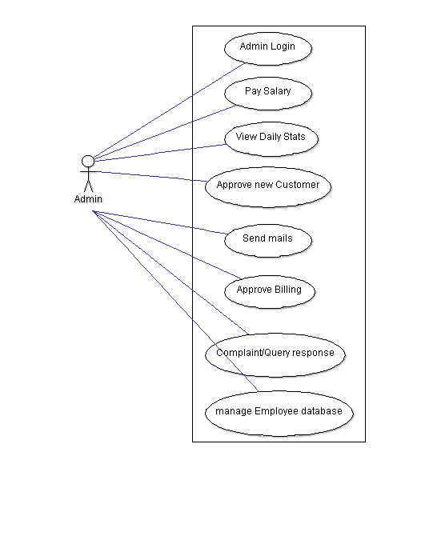222.Usecase Diagram For Guest
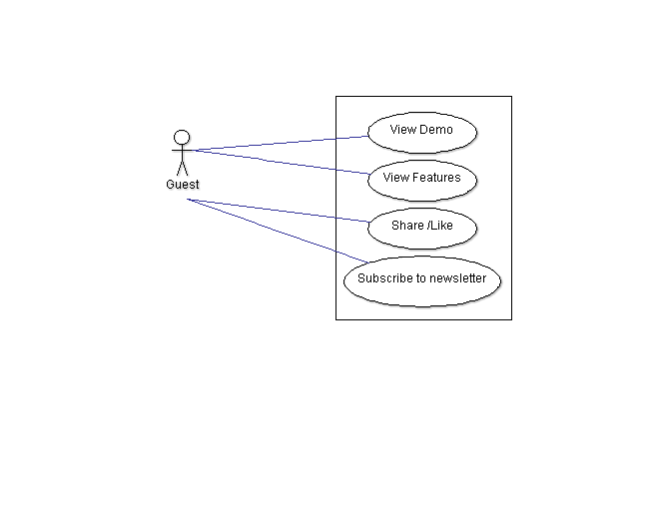

3. Usecase Diagram For Employee
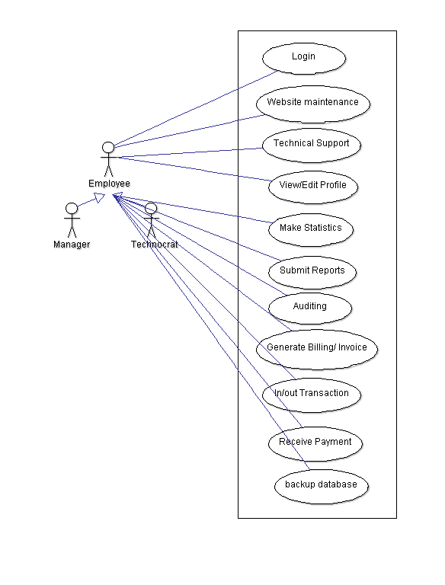

4. Usecase Diagram For Customer
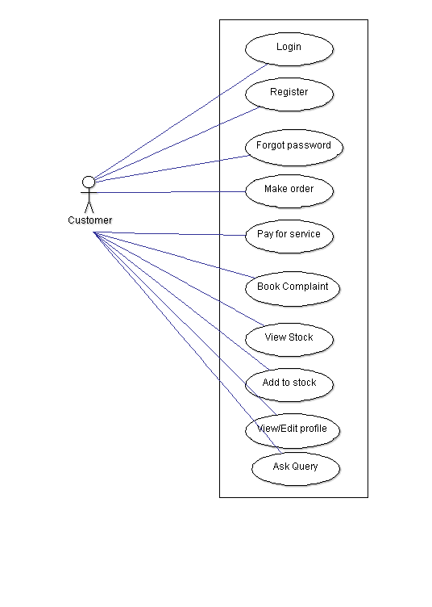

5.HARDWARE REQUIREMENTS
Processor : Intel Pentium IV and above
Hard Disk : Atleast 10 GB free space available on System Drive
RAM: 512 MB and above is better
NIC : should support atleast 10Mb/s network speed
INTERNET : ROUTER/ADSL/DSL/MODEM/DONGLE/ETHERNET LAN

6.SOFTWARE REQUIREMENTS
Operating System : windows 7 and above, LINUX
Database : MySql
Editor : Sublime text
IDE : Adobe Dream Weaver CC 2015
Client : Browser (Chrome,Firefox or IE)
Server : Apache
Web Technologies : HTML,CSS,JAVASCRIPT,BOOTSTRAP,PHP
FTP CLIENT: FILEZILLA
7. INTERFACES
User Interface: Developed using Adobe Dream weaver
Communication Interface: HTTP protocol, FTP protocol
Server maintenance: Vista control Panel

8. Implementation & Maintenance

8.1 User Manual:

8.1.1 Login:

If you (end user) want to enter into the form, then if you are admin user then you should enter through login form which checks for authorized access . If you are normal user then you to need to be created by the administrator then only this user will be allowed to start the operations. Adding the user details through registration form with your own identification name and password which gives you an unique identification to you and firm.

8.1.2 Godown Management:

Then the administrator can create a new godown in which the normal user can save transaction details regarding inwards, deliveries and returns. Whenever the transaction goes on then those details will be updated in the centralized database which helps in generating the updated reports very effectively.

8.1.3 Employees & User Management:

An administrator can create, edit and delete the employees information.
He can also create a user of type administrator or a normal employee.

9. Conclusion

The efficiency of any system designed to suit an organization depends cooperation during the implementation stage and also flexibility of the system to adopt itself to the organization.

“ONLINE WARE HOUSE ” has been developed to overcome the problems with traditional stock management in large scale. Advantages over traditional manual systems are online application access through out all the godowns from the same location, reducing the manual work, storage the data at a secured centralized locations and quick generation of reports as per our requirements.

10.References

  - Java jdk Downloads | Oracle. 2015. Downloads | Oracle. [ONLINE] Available at: https://www.oracle.com/downloads/index.html

  - Java Developer Tutorials and Online Training. 2015. [ONLINE] Available at: http://www.oracle.com/technetwork/java/index-jsp-135888.html

  - SQL Tutorial. 2015. [ONLINE] Available at: http://www.w3schools.com/sql/default.asp

  - MySQL Downloads. 2015. [ONLINE] Available at: http://www.mysql.com/downloads/

  - Apache Tomcat - Apache Tomcat 7 Downloads. 2015. [ONLINE] Available at: https://tomcat.apache.org/download-70.cgi

